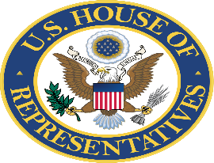

OFFICE OF CONGRESSMEMBER NANETTE DIAZ BARRAGÁN
California’s 44th Congressional District

COMMUNITY PROJECT REQUEST FORM
FISCAL YEAR 2024 APPROPRIATIONS

Thank you for your interest in submitting community project funding requests through my Congressional office. For all requests to be evaluated, please complete the form below and send to sean.kearns@mail.house.gov no later than Wednesday, March 15, 2023.

Please refer to the guidelines for individual project submissions and supporting materials on www.barragan.house.gov/community-funded-projects/.

We will evaluate each request and determine whether to submit the request to the House Appropriations subcommittees.

CONTACT INFORMATION

Organization name:

Point of contact:

Email:

Phone:

Address:

PROJECT INFORMATION

Project name:

Location of project:

Funding amount requested:

Total cost of project (include breakdown of other funding sources):

Description of project:

Explanation of how funding will be used:

How will this request benefit the constituents of California’s 44th Congressional District?

Was this request made to other Representatives or Senators? If so, please list which office(s):

APPROPRIATIONS BILL INFORMATION

Appropriations subcommittee:

Federal Agency and bureau/division:

Signature: _________________________________________

Date: ____/_____/______

